*These projects will suit students with interest and knowledge in forests, ecology, environmental physiology, terrestrial biogeochemistry, restoration ecology, conservation, physical and human geography, spatial analysis, environmental management, policy, and politics.*

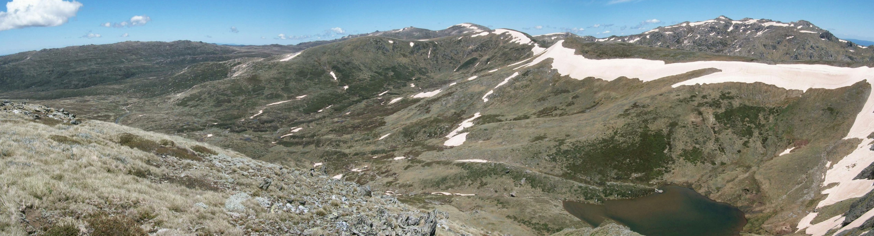

***Scholarships and Top-Ups available for***

**PhD and Honours Projects Studying**

**Snow Gum Dieback in the Australian Alps**

***Overview:*** Snow gums are amongst Australia’s most recognised trees and are iconic of the Australian Alps, with immense cultural and biodiversity values, and make broad-ranging contributions to nationally significant ecosystem services. Observations throughout the Australian high country indicate a rapid, widespread dieback of snow gums caused by a native wood-boring beetle (*Phoracantha mastersi*) exacerbated by climate change. The larvae of the beetle feed on sapwood of the trees, disrupting tree-level hydraulic function, leading to decline and eventual death.

Based on available evidence, it appears climate factors such as increasing severity of droughts underpin the prevalence of dieback, which now occurs at the landscape level where once it was found mainly in few trees and generally in isolation. In Australian subalpine ecosystems, snow gum woodlands comprise nearly the entirety of the overstorey canopy. Loss of snow gum woodlands is likely to impact ecosystem values such as water yields, local and downstream biodiversity, and ecosystem carbon stocks and sequestration capacity.

These changes present significant challenges for policy and management, necessitating management decisions against a background of uncertainty about the drivers of dieback and how ecosystem values are being altered or will be further impacted by future climate change. Landscape-scale restoration may be required to maintain ecosystem values yet will face social, technical, and institutional barriers that must be identified and addressed. These challenges are not unique to snow gum dieback. Transformational ecosystem changes are being detected in many systems around the world and equally difficult management decisions are emerging under similar scenarios in both protected areas and agricultural landscapes worldwide.

Our team is comprised of an interdisciplinary group of researchers, land managers, and other stakeholders. The research program seeks to improve our understanding of the factors driving dieback, ecosystem values impacted by these events, and to encapsulate such knowledge in models and tools to inform policy and management options to respond. We are seeking PhD and Honours students to join our team for this multidisciplinary project.

***Project Descriptions:*** There are a variety of PhD and Honours projects across the biophysical and social sciences available to examine this complex system and the challenges presented by dieback. Examples of projects and a list of potential supervisors follow.

1. ***Socio-political drivers of management and restoration*** Understanding when, where, and how to enable landscape scale restoration is ultimately a social and political process. Scientific information is just one input into this process, alongside political priorities, management policies, resource availability, and perceptions of what comprises a desirable future landscape. Understanding how these diverse factors play into, and enable or constrain management is critical to support effective management and policy options. A number of social science projects could be developed to explore this topic, ranging from studies of the policy process and the interplay between science, politics, and management; the range of current landscape values and how they may be impacted by environmental change; identification of strategies to support landscape scale restoration in the context of uncertainty; and an examination of the factors that shape when, where, and how to intervene in a changing landscape. [Contact Carina Wyborn for more information.](https://researchers.anu.edu.au/researchers/wyborn-c)

1. ***Carbon dynamics of affected and unaffected snow gum woodlands.*** Subalpine ecosystems contain vast stores of carbon in biomass as well as soils rich with organic matter. Dieback of living snow gums reduces ecosystem carbon stocks while potentially weakening the carbon sink strength through both reduction of photosynthetic input and increased output via accelerated decomposition, increased potential for biodeterioration and burning of dead wood, and greenhouse gas efflux from soils. Quantification of carbon dynamics will inform predictive land-surface and hydrological models, and will contribute to greenhouse gas budgets. This project may involve chemical analysis of soils and vegetation, *in-situ* assessment of stand structure and carbon stocks, measurement of greenhouse gas fluxes using chamber and eddy covariance techniques, and integration of observations with parameterisations and predictions of models. [Contact Zach Brown for more information.](https://biology.anu.edu.au/people/professional-staff/zachary-brown)
2. **Understanding the physiology, functional ecology and genomics of the snow gum group to inform mitigation and management.** Given the practical limitations associated with currently available and foreseeable on-ground treatments for affected stands, it will be important to understand genomic and physiological differentiation across all taxa in the snow gum group. That understanding will provide a basis for restoration. Evidence thus far indicates that the taxa may differ in their vulnerability to dieback, as well as in physiological tolerance of drought and thermal extremes. A range of projects are available in this space that will make use of high throughput phenotyping, growth trials in glasshouses, common garden experiments and provenance trials, and eco-evolutionary genomics. Together these projects will aim to provide a better understanding of differences in vulnerability to dieback among different taxa and will contribute to an increased potential for mitigation and management responses. [Contact Adrienne Nicotra for more information.](https://biology.anu.edu.au/people/academics/adrienne-nicotra)
3. **Mapping futures: modelling the geography of snow gum dieback with an eye to management planning**. Work in this space will draw on field collected data on trees of different dieback history as well as phenotyping information from experimental work to develop models of tree, stand and landscape function using the LPJ-GUESS ecosystem modelling framework. Models will allow us to explore how differences in physiological tolerance, growth allometry, stand structure, tree water use, and carbon cycling across the snow gum distribution could interact to determine the future geography of dieback. Ultimately, the models will be applied to assess scenarios of dieback trajectories and to explore costs and benefits of different management actions and prioritise potential interventions. [Contact Ben Smith for more information.](https://www.westernsydney.edu.au/hie/people/researchers/professor_ben_smith_director_of_research)

***Eligibility:*** Suitable applicants need to be highly motivated with strong academic and research backgrounds; for the biophysical science projects skills in plant ecology, ecophysiology, biogeochemistry, and/or ecological and evolutionary genetics are required. For the social sciences, a background in geography, anthropology, sociology, politics, sustainability science or cognate field, and experience with social research is required (PhD) and desirable (Honours). Demonstrated ability to conduct fieldwork and independent research experience are highly desirable. Interested students must apply for admission and scholarship [online at ANU](https://www.anu.edu.au/study/scholarships/find-a-scholarship/anu-phd-scholarships) for projects 1-4 and [online at WSU](https://www.westernsydney.edu.au/schools/grs/scholarships/main_round_scholarships) for project 4.

***Financial support:*** Top-up scholarships are available for all listed projects to augment student stipends. A limited number of scholarships are available at WSU to support Project 4: Mapping Futures. Candidates interested in the other projects will need to apply for scholarships at ANU through a competitive process. Contact the project lead for further information and application support. Successful applicants will receive a scholarship stipend, tuition fee waiver, and research funds including computer and travel grants.

***Location*:** Projects can be based in the Fenner School of the Environment and Society and/or the Division of Ecology & Evolution in the Research School of Biology, Australian National University, Canberra, Australia. Project 4 will be undertaken in collaboration between ANU and Western Sydney University’s Hawkesbury Institute for the Environment. The facilities and intellectual environment are outstanding; the research team is a lively, inclusive, hard-working and inquisitive community. We strive to do excellent research that is relevant in the context of rapid global change. Canberra is a great place to live and offers a balance of amazing bushland and outdoor activities, proximity to mountains and beaches, alongside the conveniences of a larger city.

***Application deadline:*** Applications for [international](https://biology.anu.edu.au/research/divisions/division-ecology-and-evolution/international-applicants-for-phds-in-ecology-evolution) and [domestic](https://biology.anu.edu.au/research/divisions/division-ecology-and-evolution/domestic-international-applicants-for-phds-in-ecology-evolution) students are due by *April 15* for a mid-2023 start. A second scholarship round will close August 31 (International) and Oct 31 (domestic) 2023 for an early 2024 start. For further information, please use contact info above (and for further information, go [here](http://biology.anu.edu.au/education/degree-programs#ees) and click the ‘Higher Degree by Research’ button).